Project title
BRAGE BROMSET BESTVOLD, Håkon Bekken



Preface
Red text is help text and can be removed as the project progresses.
This is a general (for both feasibility studies and design reports) report template that will be the basis for all hand-ins and the final “design sprint”. In the fist hand-in the goal is to structure this template so I mirrors the project of interest.
Remember to
- Write in the full name of the authors on the first page
About the formatting:
- Calibri or Times New Roman…. NO COMIC SANS
- Font size – 11
- Table and figure font size – 9
- Table text is placed over the table
- Figure text is placed under the figure
- Right-click on table/picture and insert caption (sett in bildetekst).
About the written language
- Norwegian or English.
- Avoid informal writing eg. “we think”, “we suggest”
  - Eg. Instead of we think; “based on the key findings in this work the project group suggest”
About references
- Use the word “reference tool”
- If a reference Is identified use the “insert quotation” and create a bibliography

Advice
- When working on the report remember to update the table of content
  - Good way of getting overview of the report as you progresses,
- When reading your report…try to make it fun
  - My personal favourite…. Read it with Sir David Attenboroughs voice.
    - https://www.youtube.com/watch?v=p1PID91sEW8

Executive summary
Executive summary - A brief summary (1-2 pages) of the key findings in the report.

------------------------------------------Introduction Paragraph ---------------------------------------------------------------------

------------------------------------------problem statement Paragraph -----------------------------------------------------------

------------------------------------------overview of the work performed Paragraph --------------------------------------------

-----------------------------------Overview of the key findings and recommendations ------------------------------------------

Sammendrag

Abbreviations
Eg.
ML – Machine Learning

List of figures
Figure 1 system architecture 13



List of Tables
Table 1 eksempel på tabell 14

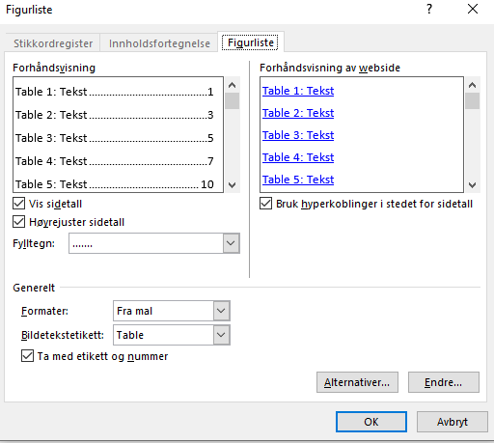
Content
Introduction 5
background 5
Problem statement 6
goals and objectives 6
Limitations 6
Implementation 7
Project plan . 7
Management, team and expertise 8
Theory and key concepts 9
Theory 9
Theory 9
Theory 9
State-of-the-art analysis - Technical review 9
Summary 9
method 10
Evaluation and results 11
Testplan 11
Simulation 11
Experimental 11
Results 11
Conclusion and recommendations 12
further work 12
references 13
Attachments 14



Introduction

background
Describe the overall background for the project… see the “how to make a good introduction” video on canvas.

The goal is shown to the reader that the problem you are working on is a real one.
Then as you progress try to introduce the topic of the project as smooth transition to problem statement

Problem statement
Introduce the problem

goals and objectives
The overall goal is to……..
In order to achieve this the following objectives and activities as been set
- Research
  - Preform a theoretical review of key concepts in order to provide a theoretical framework for understanding the project.
  - Identify state-of-art solution through a technical review
  - Research Activity
  - Research Activity
  - Provide summary
- Development/method
  - Activity
  - Activity
  - Activity
  - Provide summary
- Evaluation
  - Activity
  - Activity
  - Activity
  - Provide summary
- Recommendations and further work

Limitations
This is a crucial section…

Theory and key concepts
Present the chapter………….. usually the main objective is to present key concepts or underlying

Theory
Eg. https://www.sick.com/ag/en/condition-monitoring-in-hydraulic-and-pneumatic-systems/w/blog-fluid-power-condition-monitoring/

Theory

Theory

State-of-the-art analysis - Technical review
Review of research work
Eg. http://liu.diva-portal.org/smash/get/diva2:1420733/FULLTEXT01.pdf
https://core.ac.uk/download/pdf/81123358.pdf
https://tud.qucosa.de/api/qucosa%3A29408/attachment/ATT-0/?L=1

Summary
Present the key results from this chapter

method
Present the chapter…………..
in the first hand-in the goal is that you structure the following sub-sections in this report

some examples

design description

concept Overview
Overall description of concept

system architecture
https://www.lucidchart.com/pages/examples/flowchart-maker
https://app.diagrams.net/

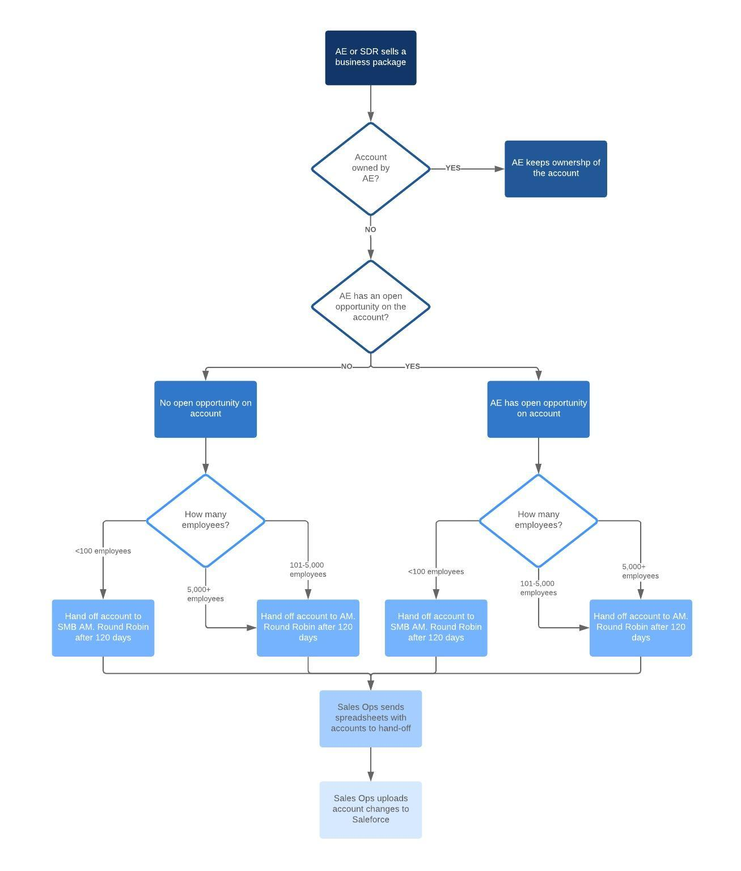
Figure 1 system architecture


System description

Summary


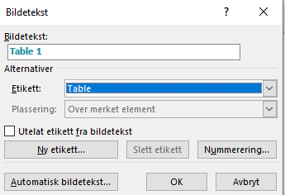

Table 1 eksempel på tabell

Evaluation and results
Present the chapter…………..

in the first hand-in the goal is that you structure the following sub-sections in this report

Testplan
Example

Simulation
Example

Experimental
Example

Results
Example

Conclusion and recommendations
Provide the reader with a reminder of project goal
What has the project group done
What is the key results?
What does the project group recommend based on the work done.

further work
Imagine you are in charge of project hand-over to a new project group
Provide a section about further work
- Improvements
- Loose threads

references
Det finnes ingen kilder i gjeldende dokument.
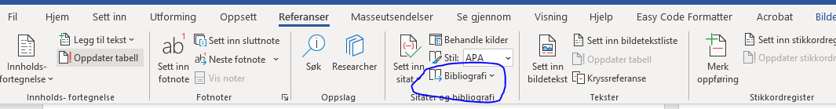

Attachments

Source code
Key source code

Link to github

